Name Muhammad Mujtaba Sharif

Reg. No 2018-AG-1633

Section B

GitHub id Mujtaba1997pak@gmail.com

***Week 1: Assignment***

Question No# 1

. Place the screenshot of CMD or Gitbash showing the version of your Java complier in the assignment file in your shared Dropbox folder.

Answer. 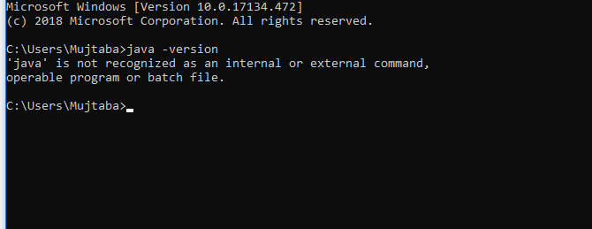

Question No# 2

. Place the screenshot of CMD or Gitbash showing the version of your git in the assignment file in your shared Dropbox Folder.

Answer. 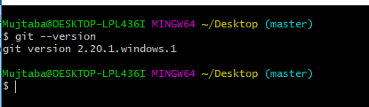

Question No # 3

. Place the screenshot of CMD or Gitbash after running **git status** command in the assignment file in your shared Dropbox folder.

Answer. 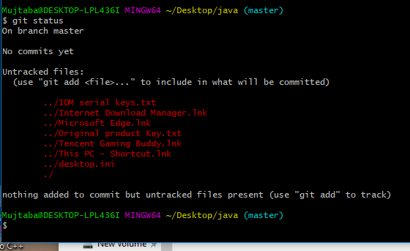

Question No# 4

. Write the following code on the note book. In front of each line of the code explain it in your own words. Place the pictures of it on the assignment file in your shared Dropbox folder.

Answer.

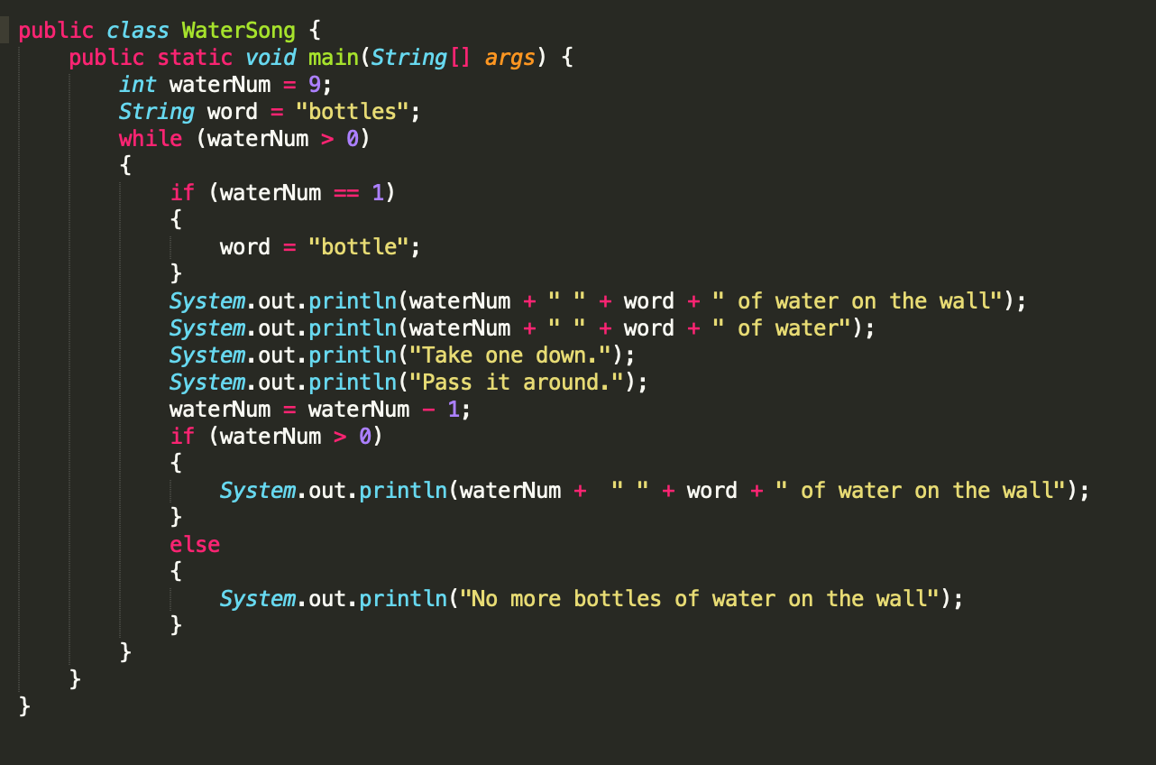

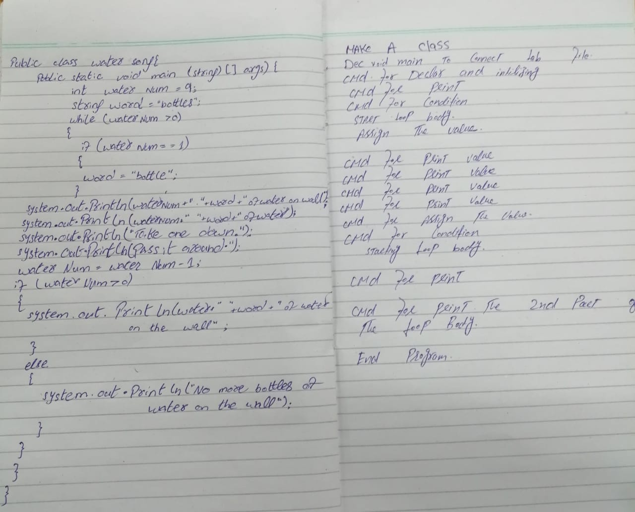

Question No# 5

. Execute the code step by step on your note book and past the pictures of it in the assignment file in your shared Dropbox folder.

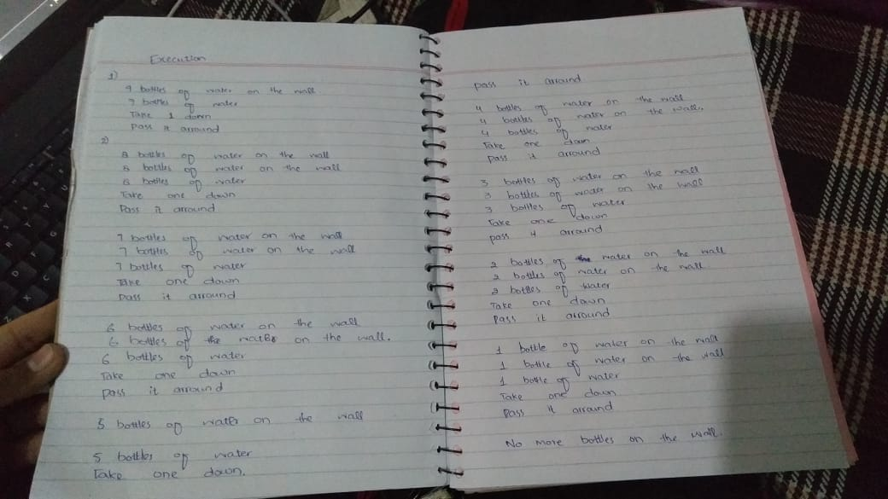

Question No# 6

. Run and compile the code. Upload it on the GitHub.

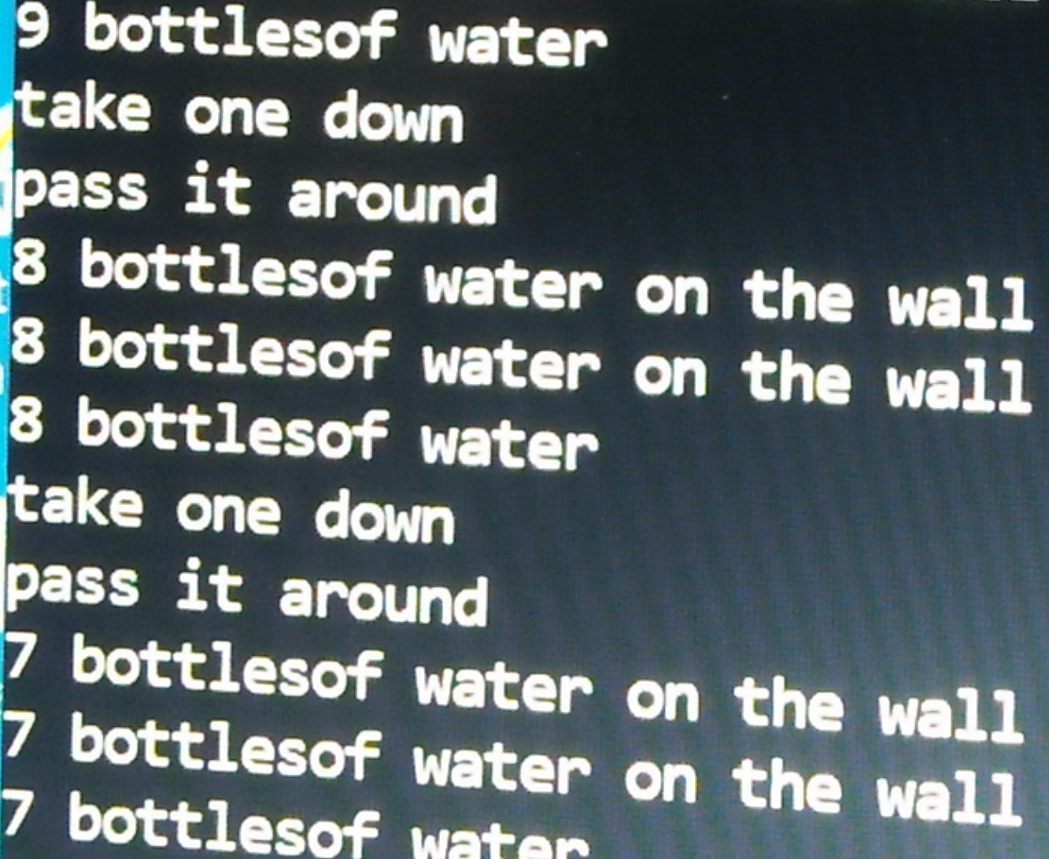

Question No# 7

. Program contains a logical error. Fix it with class name WaterSongFixed and write it down on the notebook and paste the picture of it in the assignment file in shared Dropbox folder.

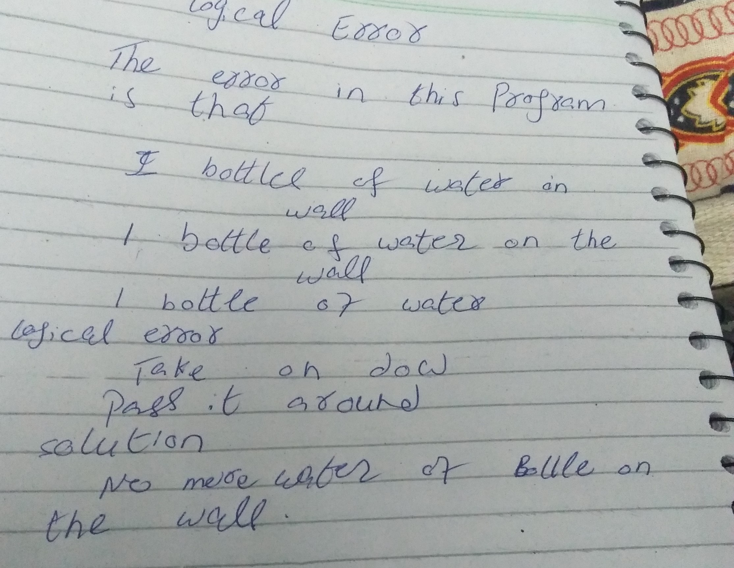

Question No# 8

. Upload WaterSongFixed on the GitHub.

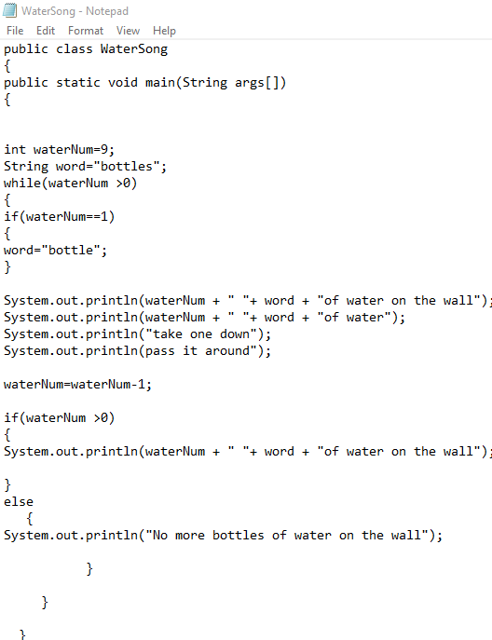

Question No # 09

. After completing all above questions, paste the screenshot of GitHub insights showing your weekly progress in the assignment file of your shared Dropbox folder.

Answer. 